Spring Data JPA with Spring Boot, Hibernate

**Spring Data JPA - Quick Example**

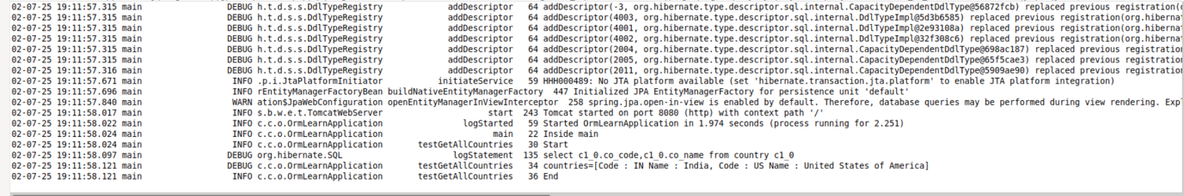

**Difference Between JPA, Hibernate, and Spring Data JPA**

**1) JPA (Java Persistence API)**

JPA is just a **specification** (a set of rules) for working with databases using Java objects.

It defines key concepts like:

@Entity – marks a class as a database table.

@Id – marks the primary key.

EntityManager – used to interact with the database.

JPA **does not contain actual code**—you need a library (like Hibernate) to use it.

**2) Hibernate**

Hibernate is a **framework** that **implements JPA** and adds extra features.

It provides the real functionality to connect Java objects with database tables.

Hibernate also includes helpful features like:

Caching

Lazy loading

Query optimization

If you use Hibernate directly, you manage sessions and transactions yourself (unless you use Spring).

**3) Spring Data JPA**

Spring Data JPA is a **part of the Spring Framework**.

It builds **on top of JPA** to make working with databases easier.

You just define **interfaces** (like EmployeeRepository), and Spring handles the database code for you.

It works smoothly with Spring Boot and handles transactions automatically.

**Code Comparison  
  
Using Hibernate (Manual Handling)**

public Integer addEmployee(Employee employee){

Session session = factory.openSession();

Transaction tx = null;

Integer employeeID = null;

try {

tx = session.beginTransaction();

employeeID = (Integer) session.save(employee);

tx.commit();

} catch (Exception e) {

if (tx != null) tx.rollback();

} finally {

session.close();

}

return employeeID;

}

**Using Spring Data JPA**

**Employee Repository**

public interface EmployeeRepository extends JpaRepository<Employee, Integer> {

}

**Employee Service**

@Autowired

private EmployeeRepository employeeRepository;

@Transactional

public void addEmployee(Employee employee) {

employeeRepository.save(employee);

}

**Implement services for managing Country**

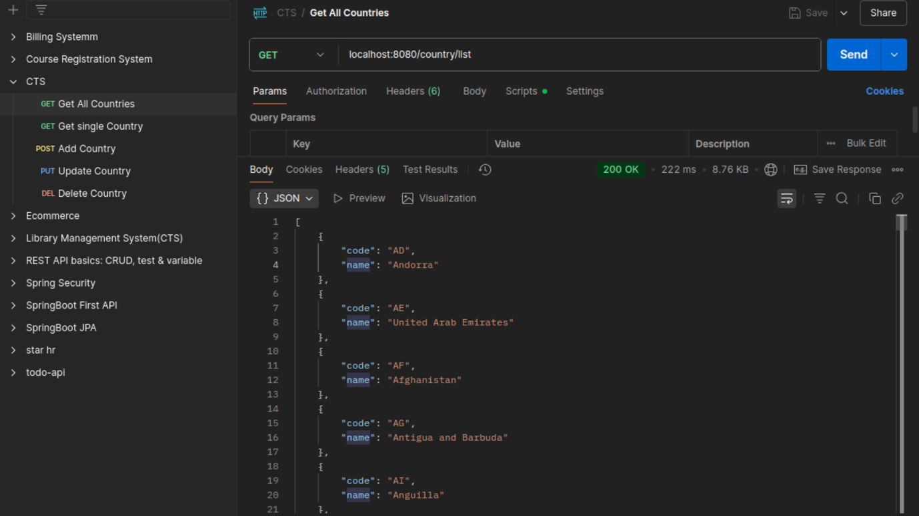  
  
  
Add a new Country  
  
